Lab Report

Your Information
Your Name: Joshua Zimmerman-Gibson
Assignment Title: Power BI Dashboard Creation

Screenshots
Step 1.2: Define Data Relationships
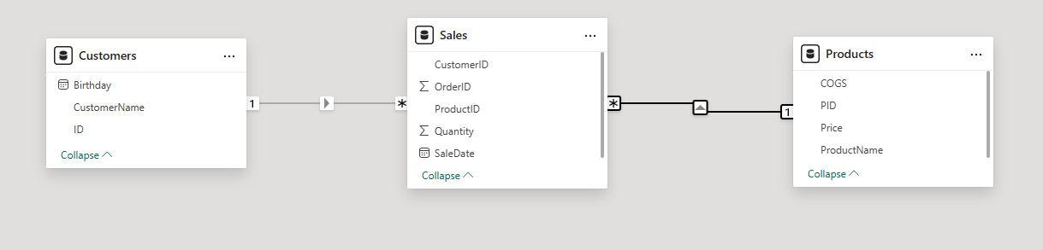
Step 1.3: Creating a Total Cost Column in Sales
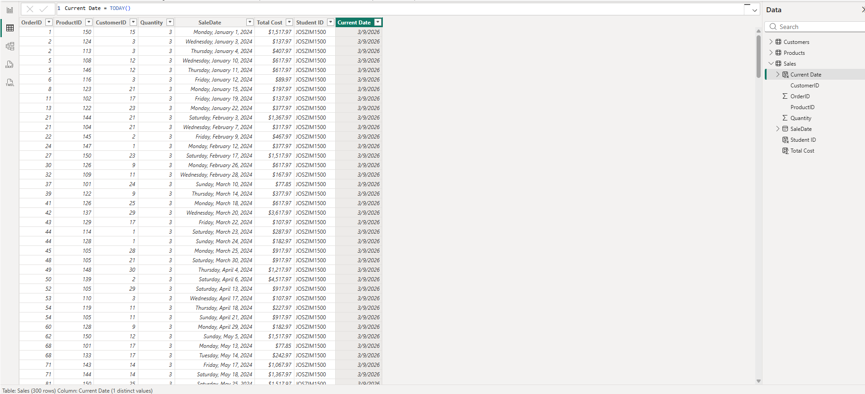
Step 1.6: Calculate Age from Birthday
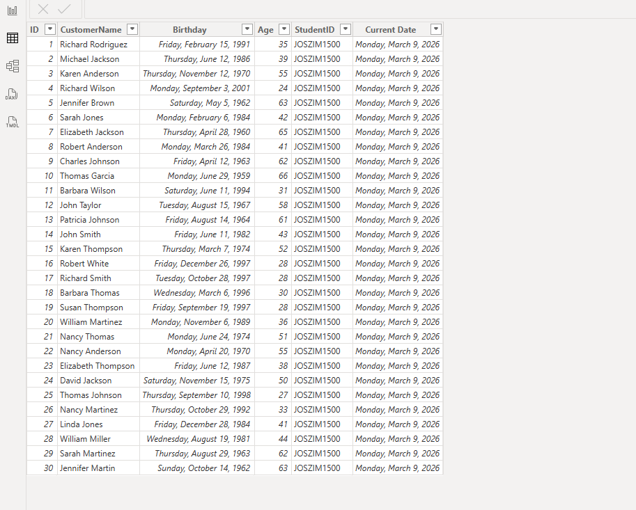
Task 2: Creating a Dashboard in Power BI
Step 2.1: Monthly Sales Overview
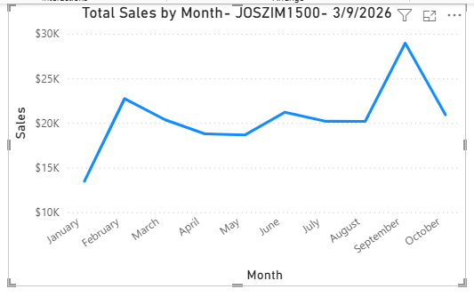
Step 2.2: Top Performing Products
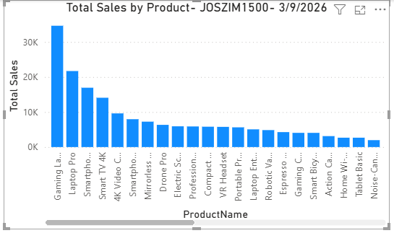
Step 2.3: Visualizing Age Distribution with a Pie Chart and Enhanced Tooltips
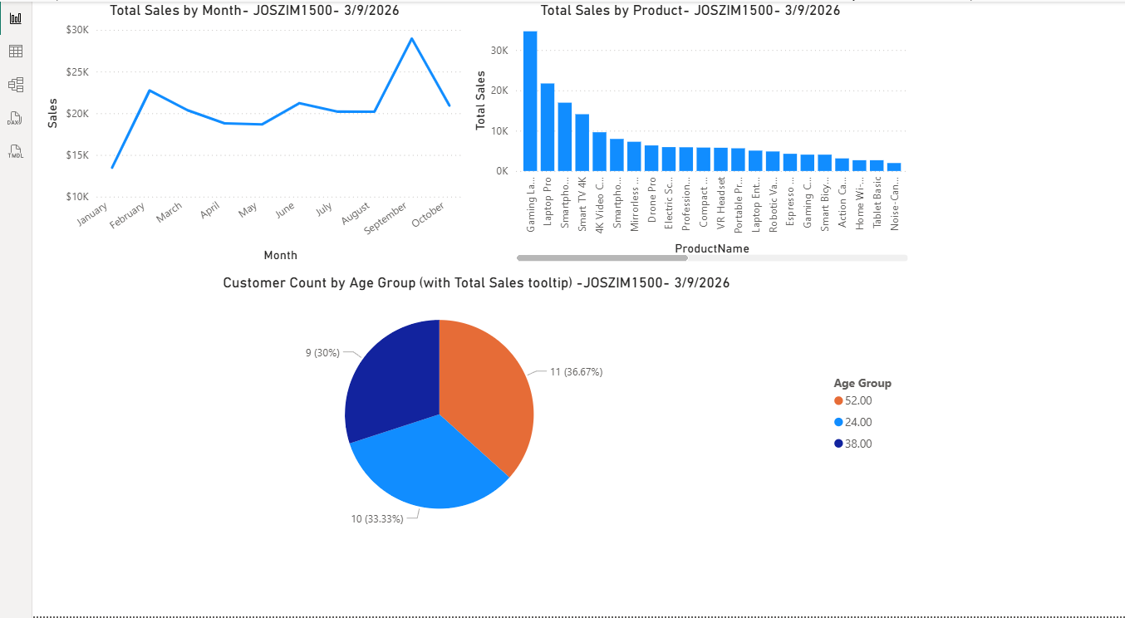

Questions
1. What is the purpose of the DAX function CALCULATE, and how does it differ from simple
aggregation functions like SUM?
The CALCULATE function is one of the most powerful tools in DAX. Its main job is to evaluate an expression (like a sum, average, or count) inside a modified filter context. In plain terms, it lets you change or add filters temporarily while calculating something, so you get results based on specific conditions, even when your report already has filters from slicers, rows, columns, or pages.
For example:
- You might want total sales, but only for a certain product category, region, or time period—CALCULATE makes that easy without creating separate tables.
Simple aggregations like SUM, AVERAGE, or COUNT just add up (or average, etc.) values in a column using whatever filters are already active in the report (the current filter context). They don't let you override or add extra conditions on their own.
Key differences:
- SUM (or similar) -> Simple total based on current filters. No way to say "but ignore this" or "add this extra rule."
- CALCULATE -> Wraps around an expression (often a SUM) and lets you modify filters. Syntax looks like: CALCULATE(SUM(Sales[Amount]), Sales[Region] = "South") This gives sales only for the South, even if the report is filtered to something else.

2. Explain how you would use the RELATED function in a calculated column to fetch data from a related table in Power BI.
The RELATED function pulls a value from a related table into your current table but only works in a calculated column (not measures), because it needs a row context to know which row you're on.
It follows an existing many-to-one relationship (like from Sales table -> Products table, where many sales point to one product).
How to use it:
- Go to the table on the "many" side (e.g., Sales table).
- Create a new calculated column.
- Write: RelatedColumn = RELATED(Products[ProductName]) This looks up the ProductName from the Products table for each sale row, using the relationship (usually via ProductID or similar key).

3. Describe how you can create a measure to calculate the average sales per customer using DAX in Power BI.
Average sales per customer means: total sales divided by the number of unique/distinct customers (not just average of individual transaction amounts).
The best way uses AVERAGEX (an iterator) combined with VALUES to loop over each unique customer and average their total sales.
Average Sales per Customer = AVERAGEX( VALUES(Customers[CustomerID]),
// or CustomerKey, CustomerName, any unique identifier
[Total Sales] // your existing measure for SUM(Sales[Amount]) or similar
)

How it works step-by-step:
- VALUES(Customers[CustomerID]) -> Gives a list of distinct customers in the current filter context (e.g., selected region, date range).
- AVERAGEX -> For each unique customer in that list, calculates [Total Sales] (how much that one customer spent), then averages those customer totals.

